Lasso Regression

Lasso regression can be perceived as an alternative fitting method to OLS and Ridge regression which can be used to overcome the disadvantage of having a large set of explanatory variables (predictors) in building a model, since the previous two techniques do not allow to discard certain predictors (in fact, OLS includes all explanatory variables and Ridge shrinks some parameters to zero, still inserting them into the model).

Lasso coefficient estimates are the ones which minimize the expression

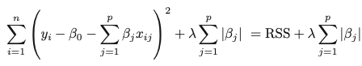

Under the constraint



Where s is a finite positive number.

The parameter λ ≥ 0 is the tuning parameter. In this case, the penalty term actually manages to force some coefficient estimates to be exactly equal to zero when λ is sufficiently large (as for Ridge, it was necessary to have λ = ∞ in order to have zero impact of some variables).

As it was for Ridge, it is extremely important to determine a correct value for λ.